PUTHIMARI COLLEGE
SONESWAR, DIST.-KAMRUP, ASSAM, PIN: 781382, Ph: 0361-288003

The Annual Quality Assurance Report (AQAR)

Session : 2013-2014

Part – A

1. Details of the Institution
PUTHIMARI COLLEGE

1.1 Name of the Institution
SONESWAR
1.2 Address Line 1
DIST. - KAMRUP
Address Line 2
SONESWAR

City/Town
ASSAM
State
781382
Pin Code
principal.puthimaricollege@yahoo.com
Institution e-mail address
0361-288003
Contact Nos.

Name of the Head of the Institution:
Dr. Nityananda Kalita

0361-288003
Tel. No. with STD Code:
+91 9864086145
Mobile:
Mr. Phuleswar Deka
Name of the IQAC Co-ordinator:
09508440600
Mobile:

Iqac.puthimaricollege@yahoo.com

IQAC e-mail address:

1.3 NAAC Track ID
15146

1.4 NAAC Executive Committee No. & Date:
EC/62/RAR/071 Dated: 05-01-2013
(For Example EC/32/A&A/143 dated 3-5-2004.
This EC no. is available in the right corner- bottom
of your institution’s Accreditation Certificate
www.puthimaricollege.in
1.5 Website address:
www.puthimaricollege.in/AQAR/2013-14.doc
AQAR10.docx
Web-link of the AQAR:

1.6 Accreditation Details
Sl. No. | Cycle | Grade | CGPA | Year of Accreditation | Validity Period
1 | 1st Cycle | C+ | - | 2005 | 2010
2 | 2nd Cycle | B | 2.34 | 2013 | 2018
3 | 3rd Cycle | - | - | - | -
4 | 4th Cycle | - | - | - | -

03/01/2005
1.7 Date of Establishment of IQAC: DD/MM/YYYY

2013-14
1.8 AQAR for the year

1.9 Details of the previous year’s AQAR submitted to NAAC after the latest Assessment and Accreditation by NAAC
i. AQAR__2012-13 Submitted to NAAC on 11/06/2016

1.10 Institutional Status
✓

University State Central Deemed Private

Affiliated College Yes No
✓

Constituent College Yes No
✓

✓

Autonomous college of UGC Yes No

✓

Regulatory Agency approved Institution Yes No

(eg. AICTE, BCI, MCI, PCI, NCI)
✓

Type of Institution Co-education Men Women

✓

Urban Rural Tribal

Financial Status Grant-in-aid UGC 2(f) UGC 12B
✓

✓

Grant-in-aid + Self Financing Totally Self-financing

1.11 Type of Faculty/Programme
✓

Arts Science Commerce Law PEI(Phys Edu)

TEI (Edu) Engineering Health Science Management

Others (Specify)

1.12 Name of the Affiliating University (for the Colleges)
Gauhati University

1.13 Special status conferred by Central/ State Government-- UGC/CSIR/DST/DBT/ICMR etc
N.A
Autonomy by State/Central Govt. / University
N.A.

N.A

College with Potential for Excellence UGC-CPE
N.A.

N.A.

DST Star Scheme UGC-CE
N.A.

N.A.

UGC-Special Assistance Programme DST-FIST
N.A.

N.A.

UGC-Innovative PG programmes Any other (Specify)
UGC-COP Programmes
N.A

2. IQAC Composition and Activities
2.1 No. of Teachers
01
06
2.2 No. of Administrative/Technical staff
01
2.3 No. of students
2.4 No. of Management representatives
01
2.5 No. of Alumni
01
2. 6 No. of any other stakeholder and
02
Community representatives
2.7 No. of Employers/ Industrialists
-
2.8 No. of other External Experts
-
12
2.9 Total No. of members
02
loiouyr
2.10 No. of IQAC meetings held

01
-
2.11 No. of meetings with various stakeholders: No. Faculty
01
-
-
Non-Teaching Staff Students Alumni Others

✓

2.12 Has IQAC received any funding from UGC during the year? Yes No
Rs 3 lakhs.
If yes, mention the amount

2.13 Seminars and Conferences (only quality related)
(i) No. of Seminars/Conferences/ Workshops/Symposia organized by the IQAC
-

-
-
Total Nos. International National State Institution Level
-
-

-----------------------
(ii) Themes

2.14 Significant Activities and contributions made by IQAC
The IQAC has made significant contribution to the all round development of the college.

- IQAC suggested the college authority to complete previous year proposed works like construction of class room with modern IT facilities, improvement of drinking facilities within the campus etc.

- It collects feedback from the students, analyse them and gives necessary advice to improve overall teaching and learning process.

- IQAC collects self evaluation reports of individual teachers keep a record of different activities of the faculty members.

- IQAC take initiative to continue the practice of organising Departmental Seminar for the students.

- IQAC take initiatives to introduce “Group Discussion Sessions” (at Departmental level) during the academic year.

- IQAC actively monitor Student Support System.

2.15 Plan of Action by IQAC/Outcome
The plan of action chalked out by the IQAC in the beginning of the year towards quality
Enhancement and the outcome achieved by the end of the year

Plan of Action | Achievements
- To impart quality education according to the Vision and Mission, of the college.  - IQAC advised the departments to start the practice of organizing “Group Discussion” at department level.  - IQAC has decided to continue the practice of organizing the departmental seminars.  - To encourage students to take part in Sports & Games and other Co-Curricular activities.  - Decided to organize special camp at adopted village.  - Campus renovation works. | - Quality education was imparted according to the Vision and Mission, of the college.  - Two group discussion sessions had been organized during the academic year. One during the odd semester and other during the even semester.  - All Departments conducted the Departmental seminars, one each.  - Students were encouraged to take participation in sports & Games and other co-curricular activities. Accordingly Annual Function, Fresher’s Day were organised.  - Special camp had been organised at adopted village “Guiya” by the NSS unit of the college (from 21st to 27th March, 2014; Total Participants: 50 Nos.)  - Many campus renovation works have been carried on throughout the year (like flied work, building renovation etc.
Academic Calendar of the year 2013-2014 (See Annexure-1)

2.15 Whether the AQAR was placed in statutory body Yes No
✓

Management Syndicate Any other body

✓

Provide the details of the action taken
- AQAR was approved by Governing Body of the college.

- Decided to give more emphasis on ICT.

Part – B
Criterion – I

1. Curricular Aspects

1.1 Details about Academic Programmes
Level of the Programme | Number of existing Programmes | Number of programmes added during the year | Number of self-financing programmes | Number of value added / Career Oriented programmes
PhD | - | - | - | -
PG | - | - | - | -
UG | 02  (B.A. General & B.A. Major) | 0 | 0 | 0
PG Diploma | - | - | - | -
Advanced Diploma | - | - | - | -
Diploma | - | - | - | -
Certificate | - | - | - | -
Others | - | - | - | -
Total | 02 | - | - | - | -

Interdisciplinary | - | - | - | -
Innovative | - | - | - | -

1.2 (i) Flexibility of the Curriculum: CBCS/Core/Elective option / Open options: Open Options.
(ii) Pattern of programmes:
Pattern | Number of programmes
Semester | 2 (B.A. General & B.A. Major)
Trimester | -
Annual | 2 (B.A. General & B.A. Major)

1.3 Feedback from stakeholders* Alumni Parents Employers Students

✓

(On all aspects)
Mode of feedback : Online Manual Co-operating schools (for PEI)

✓

*Refer annexure IV for feedback analysis report.

1.4 Whether there is any revision/update of regulation or syllabi, if yes, mention their salient aspects.
Syllabus is determined by the affiliated University; hence it is out of scope of the college.

1.5 Any new Department/Centre introduced during the year. If yes, give details.
No new department was introduced.
Criterion – II
2. Teaching, Learning and Evaluation
2.1 Total No. of permanent faculty
Total | Asst. Professors | Associate Professors | Professors | Others
23 | 07 | 15 | 01 (Principal) | 0
04
2.2 No. of permanent faculty with Ph.D.
2.3 No. of Faculty Positions Recruited (R) and Vacant (V) during the year
Asst. Professors |  | Associate Professors |  | Professors |  | Others |  | Total
R | V | R | V | R | V | R | V | R | V
01 | - | - | - | - | - | - | - | 01 | -
-
-
10
2.4 No. of Guest and Visiting faculty and Temporary faculty

2.5 Faculty participation in conferences and symposia:

No. of Faculty | International level | National level | State level
Attended Seminars/ Workshops | 01 | 02 | -
Presented papers | 01 | 01 | -
Resource Persons | - | - | -

2.6 Innovative processes adopted by the institution in Teaching and Learning:
- Introduction of “Group Discussion Sessions” at departmental level.
- Use of supplementary aids such as charts, introducing multiple choice questions in class test and more.
- “Award of Merit “was introduced to motivate the students.

222
2.7 Total No. of actual teaching days during the academic year

2.8 Examination/ Evaluation Reforms initiated by
Introduction of MCQ in class test
the Institution (for example: Open Book Examination, Bar Coding,
Double Valuation, Photocopy, Online Multiple Choice Questions)

2.9 No. of faculty members involved in curriculum
-
-
-
restructuring/revision/syllabus development
as member of Board of Study/Faculty/Curriculum Development workshop

2.10 Average percentage of attendance of students
75%

2.11 Course/Programme wise distribution of pass percentage:

Title of the Programme | Total no. of students appeared | Total no. of students Passed | Division
Title of the Programme | Total no. of students appeared | Total no. of students Passed | Distinction % | I  % | II  % | III % | Pass %
BA (General) | 57 | 43 | - | - | - | - | 75.38%
BA (Major) | 75 | 70 | - | - | - | - | 93.33%

2.12 How does IQAC Contribute/Monitor/Evaluate the Teaching & Learning processes:
- IQAC takes initiative to continue the process of organising student seminars, class test and quiz competitions to help the students learn better.

- In addition to that, IQAC advised all departments to organised Group Discussion at departmental level.

- IQAC takes feedback from the students and gives necessary advice for improvement.

2.13 Initiatives undertaken towards faculty development
Faculty / Staff Development Programms. | Number of faculty  benefitted
Refresher courses | -
UGC – Faculty Improvement Programme | -
HRD programmes | -
Orientation programmes | -
Faculty exchange programme | -
Staff training conducted by the university | -
Staff training conducted by other institutions | -
Summer / Winter schools, Workshops, etc. | -
Others | -

2.14 Details of Administrative and Technical staff
Category | Number of Permanent  Employees | Number of Vacant  Positions | Number of permanent positions filled during the Year | Number of positions filled temporarily
Administrative Staff | 09 | 01 | - | -
Technical Staff | - | - | - | 01

Criterion – III

3. Research, Consultancy and Extension

3.1 Initiatives of the IQAC in Sensitizing/Promoting Research Climate in the institution
- IQAC encourages and advises the faculties to take part in seminars/ conference/ workshops and to present papers. They are also encouraged to submit proposals for research projects.

- The heads of the departments are advised to apply for the UGC funds which help them conduct various seminars at national levels, workshops etc.

- The IQAC also suggests the college authorities and governing bodies to sanction leaves and necessary funds for the faculties who involve themselves in the above mentioned activities.

3.2 Details regarding major projects
 | Completed | Ongoing | Sanctioned | Submitted
Number | - | - | - | -
Outlay in Rs. Lakhs | - | - | - | -

3.3 Details regarding minor projects
 | Completed | Ongoing | Sanctioned | Submitted
Number | - | - | - | -
Outlay in Rs. Lakhs | - | - | - | -

3.4 Details on research publications
 | International | National | Others
Peer Review Journals | - | - | -
Non-Peer Review Journals | - | - | -
e-Journals | - | 01 | -
Conference proceedings | - | - | -

3.5 Details on Impact factor of publications:
N.A.
N.A.
N.A.
N.A.
Range Average h-index Nos. in SCOPUS

3.6 Research funds sanctioned and received from various funding agencies, industry and other organisations
Nature of the Project | Duration  Year | Name of the  funding Agency | Total grant  Sanctioned | Received
Major projects | - | - | - | -
Minor Projects | - | - | - | -
Interdisciplinary Projects | - | - | - | -
Industry sponsored | - | - | - | -
Projects sponsored by the University/ College |  |  |  | -
Students research projects  (other than compulsory by the University) | - | - | - | -
Any other(Specify) | - | - | - | -
Total

03
02
3.7 No. of books published i) With ISBN No. Chapters in Edited Books
-
ii) Without ISBN No.

3.8 No. of University Departments receiving funds from : N.A.
UGC-SAP CAS DST-FIST

DPE DBT Scheme/funds

3.9 For colleges Autonomy CPE DBT Star Scheme
Nil

Nil

INSPIRE C E Any Other (specify)
Nil

Nil

NIL
3.10 Revenue generated through consultancy

3.11 No. of conferences organized by the Institution

Level | International | National | State | University | College
Number | - | - | - | - | -
Sponsoring agencies | - | - | - | -- | -
NIL
3.12 No. of faculty served as experts, chairpersons or resource persons

3.13 No. of collaborations
International National Any other
-
-

-

-

3.14 No. of linkages created during this year

3.15 Total budget for research for current year in lakhs :
N.A.

0.05

From Funding agency From Management of University/College
Total
0.05

3.16 No. of patents received this year
Type of Patent |  | Number
National | Applied | -
National | Granted | -
International | Applied | -
International | Granted | -
Commercialised | Applied | -
Commercialised | Granted

3.17 No. of research awards/ recognitions received by faculty and research fellows
Total | International | National | State | University | Dist | College
- |  |  | - | - | - | -
Of the institute in the year

3.18 No. of faculty from the Institution
Nil
who are Ph. D. Guides
and students registered under them
Nil

3.19 No. of Ph.D. awarded by faculty from the Institution
Nil

3.20 No. of Research scholars receiving the Fellowships (Newly enrolled + existing ones)

JRF SRF Project Fellows Any other
Nil
Nil

Nil

Nil

3.21 No. of students Participated in NSS events
Nil

Nil

University level State level
National level International level
03

Nil

3.22 No. of students participated in NCC events:
NA

University level State level
NA

National level International level
NA

NA

3.23 No. of Awards won in NSS:
Nil

Nil

University level State level
National level International level
Nil

Nil

3.24 No. of Awards won in NCC:
NA

University level State level
NA

National level International level
NA

NA

3.25 No. of Extension activities organized
-

University forum College forum
-
01
-
NCC NSS Any other

3.26Major Activities during the year in the sphere of extension activities and Institutional Social Responsibility
- Many departmental field surveys were carried on.

- Independence Day, Republic Day, Gandhi Jayanti, Teacher’s Day, International Women’s Day and World Environment Day were observed.

Criterion – IV

4. Infrastructure and Learning Resources

4.1 Details of increase in infrastructure facilities:

Facilities | Existing | Newly created | Source of Fund | Total
Campus area | 610820.24 sq ft  (35 bigha) | - | - | 610820.24 sq ft  (35 bigha)
Class rooms | 20 (13044 sq ft) |  |  | 19 (12276 sq ft)
Laboratories | 03 (2146 sq ft) |  |  | 03 (2146 sq ft)
Seminar Halls | -
No. of important equipments purchased (≥ 1-0 lakh) during the current year. *** | - | 01 | - | _
Value of the equipment purchased during the year (Rs. in Lakhs) | - | 37,800/- | UGC | _
Others: (Principal Room, Office Room, Library, Departmental Room, Exam Control Room, Store Room, Canteen, Girls’ common room, Ladies Dressing Room, Boys’ common room , Union Room, Principal Quarter and cycle stand) | 19224 sq ft | - | - | 19224 sq ft
*** Laptop: 01

4.2 Computerization of administration and library

- Sufficient numbers of computers have been installed in the administrative office and Library.

- SOUL 2.0 Software (for Library) has been installed for smooth functioning.

4.3 Library services:

 | Existing |  | Newly added |  | Total
 | No. | Value | No. | Value | No. | Value
Text Books | 7200 | 1235000/- | 316 | 28000/- | 7516 | 1263000/-
Reference Books | 3377 | 825000/- | 100 | 32000/- | 3477 | 857000/-
e-Books | N-List Programme (INFLIBNET Membership)
Journals | 20 | 8000/- | Nil | Nil | 20 | 8000/-
e-Journals | N-List Programme (INFLIBNET Membership)
Digital Database | 01 | 2000 | Nil | Nil | 01 | 2000
CD & Video | 25 | Nil | Nil | Nil | 25 | Nil
Others (specify): | Nil | - | - | - | - | -

4.4 Technology up gradation (overall)

 | Total Computers | Computer Labs | Internet | Browsing Centres | Computer Centres | Office | Departments | Others
Existing | 25 | - | 06 | - | 06 | 05 | 08 | 06
Added | 02 | - | 07 | - | - | 02 | - | -
Total | 27 | - | 13 | - | 06 | 07 | 08 | 06
*Others: Principal Office-02, Library-03 and IQAC-01.
**Newly Added: Office: 02.

4.5 Computer, Internet access, training to teachers and students and any other programme for technology
Up-gradation (Networking, e-Governance etc.)

As of now there was no such training programs conducted. However the IQAC has a plan to provide formal training to the faculties on ICT in the future.

4.6 Amount spent on maintenance in lakhs :
- Computer &Photocopier Servicing Charge: Rs 27,700/-
- Internet Bill: Rs 24,738/-

i) ICT

- Campus Renovation and Infrastructure Maintenance Cost (Like field filling, building renovation, water supply, Motor Servicing etc.): Rs 1,62,090 /-

ii) Campus Infrastructure and facilities

-

iii) Equipments

- Practical Materials: Rs 19,000/-
- Electricity Bill/ Electricity Work: Rs 1,22,293/-
- D.G. Servicing: Rs 5,420/-

iv) Others

Rs 3,61,241/- ***
Total:

*** Rs. 3.61 Lakhs (Approx).

Criterion – V

5. Student Support and Progression
5.1 Contribution of IQAC in enhancing awareness about Student Support Services
- The IQAC organised meetings with the students to bring awareness about student support services which are available in the college.
- Separate hand outs are given to the students for enrolling themselves in NSS.
- The IQAC has requested the departments to provide the major students a copy of the syllabus.

5.2 Efforts made by the institution for tracking the progression
- Student’s performance in class test, unit test, and sessional exams are carefully evaluated to track the progression of the students.
- There is no formal mechanism in the college to track the progress of the passed out students. However, progress is often tracked at informal level through alumni feedback, word of mouth etc.

5.3 (a) Total Number of students
UG | PG | Ph. D. | Others
677 | - | - | -
NO %
327 48.30
Men : NO Women: NO %
350 51.69
Nil
(b) No. of students outside the state
Nil
(c) No. of international students
Last Year |  |  |  |  |  | This Year
General | SC | ST | OBC | Physically Challenged | Total | General | SC | ST | OBC | Physically Challenged | Total
401 | 45 | Nil | 128 | - | 574 | 460 | 26 | Nil | 191 | 02 | 677

Demand ratio : 1:1.12 Dropout: 4.18%

5.4 Details of student support mechanism for coaching for competitive examinations (If any)

The Information and Guidance Cell of the College is taking initiatives in this regard. Support is provided at informal level for entry to services.

No. of students beneficiaries
-

5.5 No. of students qualified in these examinations: College has no search mechanism.
Nil

Nil

Nil

Nil

NET SET/SLET GATE CAT

IAS/IPS etc State PSC UPSC Others
Nil

Nil

Nil

Nil

5.6 Details of student counselling and career guidance

- Information and Guidance Cell periodically provides various career related information and guidance to the students community of the college. The cell also organized some discussion with students which really benefited the students.

- IQAC timely counsel and take initiative to guide the students regarding career options after completing graduate course.

677
No. of students benefitted

5.7 Details of campus placement
On campus |  |  | Off Campus
Number of Organizations Visited | Number of Students Participated | Number of Students Placed | Number of Students Placed
- | - | - | -

5.8 Details of gender sensitization programmes
- The College has an active Women Cell which look after this work.

5.9 Students Activities
5.9.1 No. of students participated in Sports, Games and other events:
State/ University level National level International level
-
-
-

No. of students participated in cultural events:
State/ University level National level International level
-
-

-

5.9.2 No. of medals /awards won by students in Sports, Games and other events
-

-

-
Sports : State/ University level National level International level

Cultural: State/ University level National level International level
-

-

-

5.10 Scholarships and Financial Support
 | Number of  Students | Amount
Financial support from institution | 5 | Rs 11,550/-
Financial support from government | 118 | Rs 2,96,040/-
Financial support from other sources | - | -
Number of students who received International/ National recognitions | - | -

5.11 Student organised / initiatives
-
-
-

Fairs : State/ University level National level International level
-
Exhibition: State/ University level National level International level
-

-

2
5.12 No. of social initiatives undertaken by the students (***Plantation and Special camp at adopted village)

5.13 Major grievances of students (if any) redressed:

No major grievances of students had been addressed.

Criterion – VI

6. Governance, Leadership and Management
6.1 State the Vision and Mission of the institution
- Vision: To impart education in humanities to the young generation of the country and to enroute them to the world of working knowledge.

- Mission:

- To impart quality education to the students in the field of humanities.

- To empower the students through education and to prepare them to meet the challenges of the competitive world by instilling confidence in them.

- To make students socially and ethically responsible citizens.

- To dignify the future of the students by acquiring knowledge for practical world.

6.2 Does the Institution has a management Information System
The institution does not have a Management Information System.

6.3 Quality improvement strategies adopted by the institution for each of the following:
6.3.1 Curriculum Development
- Being affiliate of the university the college follows the curriculum prescribed by Gauhati University.

- The teachers prepared their lesson planning according to the class routine allotted to them and the lesson plan was executed. If any class was dropped due to some unavoidable circumstances, the class was taken by the concerned teacher on other teaching days to make up the loss.

6.3.2 Teaching and Learning
- The teaching-learning process is at the core of the academic activity of the college. As per the syllabus of Gauhati University, the number of classes to be taken is closely followed and class routine is prepared likewise. The classes, dropped for some unavoidable reasons, are taken on other teaching days to make up the loss.
- Departmental level Group Discussion Sessions has been introduced newly.
- Each department adopts innovative processes in teaching and learning like Quiz, Departmental seminars etc.
- IQAC collects student’s feedback on teaching and learning process; analysed them and share the report for betterment.

6.3.3 Examination and Evaluation
- The Final examinations are conducted as per the directives of Gauhati University. However, internal examinations are conducted by the college. The scoring of the students in the internal examinations, the percentage of their attendance in the classes etc. are taken into account in determining the internal marks of the students.

- In addition to that, departments also conducts class tests, group discussion etc. to assess the progression of students.

6.3.4 Research and Development
The IQAC encourages the faculty members to be engaged with major and minor research activities.

6.3.5 Library, ICT and physical infrastructure / instrumentation
- The Central Library has been subscribed for INFLIBNET membership (N-List Programme) which facilitates access of information of various types such as online databases, e-journals, e- books etc.

- Internet facility has been provided to the central library.

- In addition to that, the institution adopts policies and strategies for adequate technology deployment and maximum possible modernisation within the limit of funding.

6.3.6 Human Resource Management
- There is a Governing body as a top level management that manages and develops the total human resource of the college.

- Recruitment of faculties is governed by State Govt. Policies. However, college also recruits temporary faculties based on qualification.

- The college has a students’ union whose elections were held.

6.3.7 Faculty and Staff recruitment
- Faculty and staff are recruited transparently as per Government norms/rules.

- Apart from that the College also appoints faculties on contractual basis.

- Advertisements inviting applications from qualified candidates are published in leading newspapers. Application who meets the eligibility criteria lay down by the UGC and the Gauhati University are called for an interview.

6.3.8 Industry Interaction / Collaboration
There is no formal mechanism for industrial collaboration.

6.3.9 Admission of Students
Admission of students is very transparent and done purely on merit basis. Admission done as per University guidelines and Govt. rules. As the college is situated in a rural area and the number of higher secondary school is limited from which students come to take admission, the college has to admit almost all the students applying for admission.

In order to promote ICT among the staff and the students, the college is planning to initiate computerization of admission process.

6.4 Welfare schemes for
Teaching | Group Insurance Scheme and GPF
Non teaching | Group Insurance Scheme and GPF
Students | - Financial assistance from college fund for economically weaker but meritorious students.  - Award of Merit.  - Separate book bank is maintaining in the central library for economically weaker section of students.
6.5 Total corpus fund generated
16, 56, 970/-
✓

6.6 Whether annual financial audit has been done Yes No

6.7 Whether Academic and Administrative Audit (AAA) has been done?
Audit Type | External |  | Internal
Audit Type | Yes/No | Agency | Yes/No | Authority
Academic | No |  | No
Administrative | No |  | No

6.8 Does the University/ Autonomous College declare results within 30 days?
✓

For UG Programmes Yes No

For PG Programmes Yes No

N.A

6.9 What efforts are made by the University/ Autonomous College for Examination Reforms?
N.A.

6.10 What efforts are made by the University to promote autonomy in the affiliated/constituent colleges?
N.A

6.11 Activities and support from the Alumni Association
The alumni association timely gives valuable suggestions regarding student support services.

6.12 Activities and support from the Parent – Teacher Association
There is no formal parent teachers association.

6.13 Development programmes for support staff
Yet no special development program had been initiated. The IQAC has a plan to arrange a computer training session for non-teaching staff.

  - Initiatives taken by the institution to make the campus eco-friendly
- World Environment Day was observed on 5th June, 2014.
- Tree Plantation.

Criterion – VII

7. Innovations and Best Practices
7.1 Innovations introduced during this academic year which have created a positive impact on the functioning of the institution. Give details.

- The existing practice of organising weekly departmental seminars for students, giving home assignments to the students and holding class/unit tests are continued. This practice keeps the students with an opportunity to prepare research papers under the active guidance of the faculty members and enable them to interact among themselves and with the teachers.
- Two departmental level group discussion sessions had been organised during the academic year. (Newly introduced).
- In order to promote social responsibility among the students, the NSS unit of the College had organised a special camp at adapted village “Gniya” from 21st -27th March, 2014 where 50 nos. of NSS volunteers had been participated.

7.2. Provide the Action Taken Report (ATR) based on the plan of action decided upon at the beginning of the year

- Quality education was imparted according to the Vision and Mission, of the college.
- Two group discussion sessions had been organized during the academic year. One during the odd semester and other during the even semester.
- All Departments conducted the Departmental seminars, one each.
- Students were encouraged to take participation in sports & Games and other co-curricular activities. Accordingly Annual Function, Fresher’s Day were organised.
- Special camp had been organised at adopted village “Gniya” by the NSS unit of the college (from 21st to 27th March, 2014; Total Participants: 50 Nos.)
- Many campus renovation works have been carried on throughout the year (like flied work, building renovation etc.

7.3. Give two Best Practices of the institution (please see the format in the NAAC Self-study Manuals)
- Computer Education for Students (Compulsory for B.A. 1st Year)
- Departmental seminars.

See Annexure-III
7.4 Contribution to environmental awareness / protection
- World Environment Day was observed in the college.
- Tree Plantation.

7.5 Whether environmental audit was conducted? Yes No

√

7.6 Any other relevant information the institution wishes to add. (for example SWOT Analysis)
SWOT Analysis.
*(Refer annexure II)
8. Plans of institution for next year
- To give more emphasis on Teaching and Learning.
- Special emphasis will be given to lower the dropout rate.
- To purchase office automation software and salary software.
- To increase number of extension work.
- Administrative and Examination reforms.

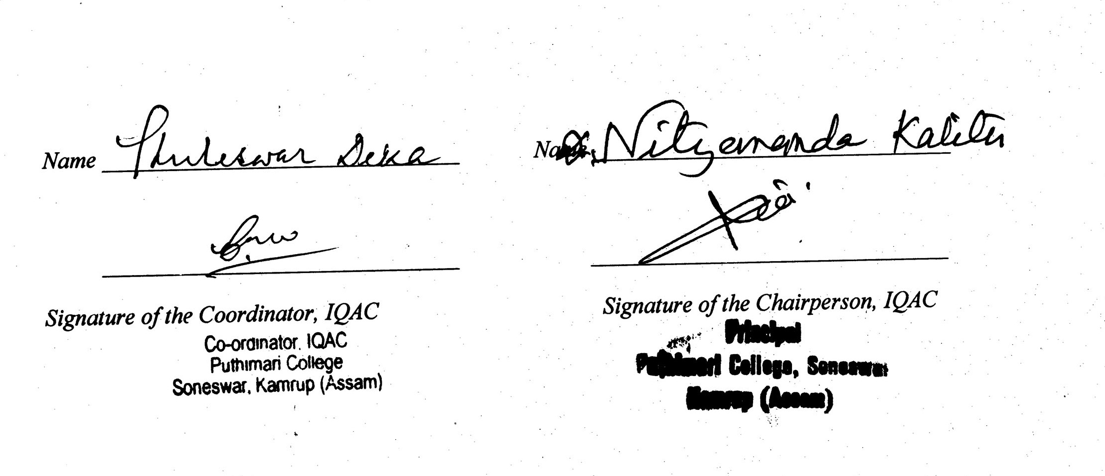

Annexure I
Academic Calendar: 2013-2014
Puthimari College, Soneswar, Kamrup, Assam

Month & Year | Working Days | Teaching Days | Exam.  Days | Programmes Observed | Sundays | Holidays
July, 2013 | 1-6, 8-13, 15-20, 22-27, 29-31 | NIL | NIL |  | 7, 14, 21, 28 | 1-31 Summer Vacation
Total | 27 | NIL |  |  | 4
August, 2013 | 1-3, 5-6, 8, 12-14, 16, 17, 19-24, 26, 27, 29-31 | 1-3, 5-6, 8, 12-14, 16, 17, 19-24, 26, 27, 29-31 | NIL | 15th –Independence Day  17- Freshers’ Social | 4, 11, 18, 25 | 09-10- Id-Ul-Fitre  15 – Independence Day  17- Freshers’ Social  25 –Tithi of Sri Madhab Deva  28- Janmastami
Total | 23 | 22 |  |  | 4 | 06
Sept.,  2013 | 2-6, 9-14, 16-21, 23-28, 30 | 2-6, 9-14, 16-21, 23-28, 30 | Sessional I exam | 5th –Teachers’ Day  14th- Election of Students Union | 1, 8, 15, 22, 29 | 7- Tithi of Srimanta Sankar Deva
Total | 24 | 23 |  |  | 5 | 1
Oct., 2013 | 1, 3-5, 7-10, 19, 21-26,  28-31 | 1, 3, 5, 7-10, 19, 21-26, 28-31 | Sessional II exam |  | 6, 13, 20, 27 | 2- Birthday of Mahatma Gandhi  11-18- Durga Puja, Janmotsav of Srimanta Sankar Deva, Id-Ul-Zuha, Kati Bihu & Laxmi Puja,
Total | 19 | 19 |  |  | 4 | 9
Nov., 2013 | 1, 4-9, 11-13, 15,16, 18-23, 25-30 | 1, 4-9, 11-13, 15, 16, 18-23, 25-30 |  |  | 3, 10, 17, 24 | 2-3- Kali Puja & Dewali  14- Maharam  17- Gurunanak Birth Day
Total | 24 | 24 |  |  | 4 | 4
Dec., 2013 | 2-7, 9-14, 16-21, 23, 24, 26-28, 30,31 | 2-7, 9-14, 16-21 | Odd Sem. Exam. |  | 1, 8, 15, 22, 29 | 25- Christmas Day  21- Millad A Mehphil
Total | 25 | 17 |  |  | 5 | 1
Jan., 2014 | 1-4, 6-11, 18, 20-25, 27-31 | 18, 20-25, |  | 17- Shilpi Divas  26- Republic Day.  27-31- College Week | 5, 12, 19, 26 | 13-17- Magh Bihu, Shilpi Divas  26- Republic Day.
Total | 22 | 07 |  |  | 4 | 6
Feb., 2014 | 1, 3, 5-8, 10-15, 17-22, 24-26, 28 | 1, 3, 5- 8, 10-15, 17-22,24-26, 28 |  | 4-Saraswati Puja, | 2, 9, 16, 23 | 4- Saraswati Puja  27- Shivaratri
Total | 22 | 22 |  |  | 4 | 2
March, 2014 | 1, 3-8, 10-15, 17-22, 24-29, 31 | 1, 3-8, 10-15, 17-22, 24-29, 31 |  | 8-International Women’s Day, | 2, 9, 16, 23, 30 | 16- Dol Yatra
Total | 26 | 26 |  |  | 5 | 1
April, 2014 | 1-5, 7-12, 17-19, 21-26, 28-30 | 1-5, 7-12, 17-19, 21-26, 28-30 | Sessional 2nd Exam (even sem) |  | 6, 13, 20, 27 | 14-16- Bohag Bihu
Total | 23 | 23 |  |  | 4 | 3
May, 2014 | 1-3, 5-10, 12-17, 19-24, 26-31 | 1-3, 5-10, 12-17, 19-24, 26-31 |  |  | 4, 11, 18, 25
Total | 27 | 27 |  |  | 4
June, 2014 | 2-7, 9-14, 16-21, 23-28, 30 | 2-7, 9-14 | Even Sem. Exam. | 5- World Environment Day | 1, 8, 15, 22, 29
Total | 25 | 12 |  |  | 5
Grand Total | 287 | 222 |  |  | 52 | 64  (Including Summer Vacation)

Note:
1. Sessional I Exam (Odd Sem.) - 2-6 Sept’2013
Sessional II Exam (Odd Sem.) - 25th -26th & 28th -31st Oct., 2013

Sessional I Exam (Even Sem.) - 17-22nd Feb.’2014
Sessional II Exam (Even Sem.) - 07-12nd April’2014

2. Departmental Seminar (Odd Sem.) ( Asm & PSc Dept.) – 25th Sept’2013
Departmental Seminar (Odd Sem.) ( Eco. & Phil. Dept.) – 26th Sept’2013
Departmental Seminar (Odd Sem.) ( Edn. & Hist. Dept.) – 27th Sept’2013
Departmental Seminar (Odd Sem.) ( Eng. & Geo. Dept.) – 28th Sept’2013

Departmental Seminar (Even Sem.) ( Eng. & Geo. Dept.) – 10th March, 2014
Departmental Seminar (Odd Sem.) ( Edn. & Hist. Dept.) – 11th March, 2014
Departmental Seminar (Odd Sem.) ( Eco. & Phil. Dept.) – 12th March, 2014
Departmental Seminar (Odd Sem.) ( Asm & PSc. Dept.) – 13th March, 2014

3. Educational Flied Trip: 1st & 3-5th Oct.’2013

4. Group Discussion: 4th -9th Nov., 2013
Group Discussion: 21st-26th April, 2014

5. End Sem. Exam (Odd): 2-7th & 9-14th Dec., 2013
End Sem. Exam (Even): 2-7th & 9-14th June, 2014
Annexure II

SWOT ANALYSIS
Strength | - Qualified and hard working teaching and non-teaching staff.  - Well equipped Library and Labs.  - Pollution free green campus.  - Good relationship among faculty members, students and non-teaching staff.
Weakness | -Majority of the students comes from economically as well as educationally backward society.  - Poor transportation system.  - Lesser IT Empowerment of Faculty and staff.
Opportunities | - Adequate Campus area.  - UGC and State Government Funds.  - Expertise of faculty to tap the corporate sector for consultancy and funding for research projects.
Threats | -Flood problem.  - Students absenteeism.  - Perception that all educational processes should be directed towards preparing students for jobs.

Annexure III

Best Practice

Practice – 1

Title- Computer Education for Students (Compulsory for B.A. 1st Year)

Objective: To equip students with skills in computer operation for meeting basic academic needs.

Context: The need to improve the skill & employability of undergraduates is addressed by this practice.

The Practice: All BA first year students are given compulsory computer training in order to acquire minimum computer knowledge at the degree level. For that, the College has established a computer lab cum class room with adequate numbers of computer systems.

Evidence of Success: Many students (especially non-computer students) have acquired adequate computing skills.

Resources: The College has established a computer lab cum class room with adequate numbers of computer systems and arranged one temporary staff for teaching purpose. As financial recourse, the college collect Rs 100/- from all BA 1st Year students at the time of admission.

Contact:
Name of the Principal: Dr. Nityananda Kalita
Name of the Institution: Puthimari College
City: Soneswar, Kamrup, Assam
Pin: 781382
Work Phone: 0361-288003
Website: www.pyuthimaricollege.in

Practice – 2

Title- Departmental Seminar

Objective –To infuse seminar culture among the students so as to compete with other students when they finally passed out from the college.
Context – The faculty of the college helps the students in preparing the seminar papers from their prescribed courses/syllabus.
Practice – The students are asked to present their papers and acquire information about the topic by asking the questions related to the topic and reading text books and reference books.
Evidence of Success – As a result of such activity, it has been observed that our students make a mark even outside the college whenever they get a chance.
Resource – No financial investment is required.

Contact:
Name of the Principal: Dr. Nityananda Kalita
Name of the Institution: Puthimari College
City: Soneswar, Kamrup, Assam
Pin: 781382
Work Phone: 0361-288003
Website: www.pyuthimaricollege.in

Annexure: IV

Student’s Feedback Analysis

(Feedback was taken in a scale of 10, with 10 being the highest rating)

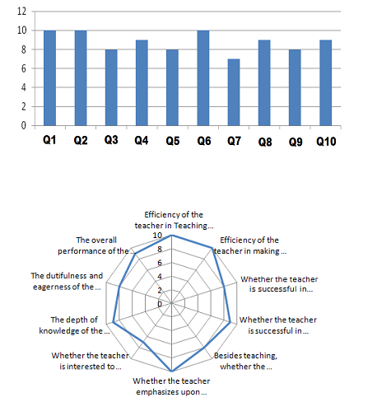

Students’ Feedback Collected During the Academic Year 2013-14 (Samples)

Student | Efficiency of the teacher in Teaching and Learning. | Efficiency of the teacher in making the course interesting and attractive. | Whether the teacher is successful in his exercise to relate environment with the subject concerned. | Whether the teacher is successful in making relationship of the subject matter with other subjects. | Besides teaching, whether the teacher is ready to respond to the discussion of the subjects by students. | Whether the teacher emphasizes upon enlarging the ideas of students in other subjects by holding quiz, spot examination, seminar etc. | Whether the teacher is interested to know if the students are able to understand his/her teaching. | The depth of knowledge of the teacher. | The dutifulness and eagerness of the teacher for his profession. | The overall performance of the teacher.
Student 1 | 8 | 10 | 9 | 9 | 10 | 9 | 8 | 9 | 9 | 8
Student 2 | 8 | 7 | 8 | 8 | 5 | 7 | 8 | 10 | 10 | 10
Student 3 | 7 | 9 | 10 | 8 | 8 | 10 | 9 | 9 | 10 | 9
Student 4 | 9 | 10 | 9 | 9 | 10 | 9 | 10 | 9 | 9 | 10
Student 5 | 8 | 10 | 9 | 9 | 10 | 9 | 8 | 9 | 9 | 8
Student 6 | 8 | 7 | 8 | 8 | 5 | 7 | 8 | 10 | 10 | 10
Student 7 | 7 | 9 | 10 | 8 | 8 | 10 | 9 | 9 | 10 | 9
Student 8 | 9 | 10 | 9 | 9 | 10 | 9 | 10 | 9 | 9 | 10
Student 9 | 8 | 10 | 9 | 9 | 10 | 9 | 8 | 9 | 9 | 8
Student 10 | 8 | 7 | 8 | 8 | 5 | 7 | 8 | 10 | 10 | 10
Student 11 | 7 | 9 | 10 | 8 | 8 | 10 | 9 | 9 | 10 | 9
Student 12 | 9 | 10 | 9 | 9 | 10 | 9 | 10 | 9 | 9 | 10
Student 13 | 8 | 10 | 9 | 9 | 10 | 9 | 8 | 9 | 9 | 8
Student 14 | 7 | 9 | 10 | 8 | 8 | 10 | 9 | 9 | 10 | 9
Student 15 | 9 | 10 | 9 | 9 | 10 | 9 | 10 | 9 | 9 | 10
Student 16 | 8 | 10 | 9 | 9 | 10 | 9 | 8 | 9 | 9 | 8
Student 17 | 9 | 10 | 9 | 9 | 10 | 9 | 10 | 9 | 9 | 10
Student 18 | 8 | 10 | 9 | 9 | 10 | 9 | 8 | 9 | 9 | 8
Student 19 | 7 | 9 | 10 | 8 | 8 | 10 | 9 | 9 | 10 | 9
Student 20 | 8 | 10 | 9 | 9 | 10 | 9 | 8 | 9 | 9 | 8

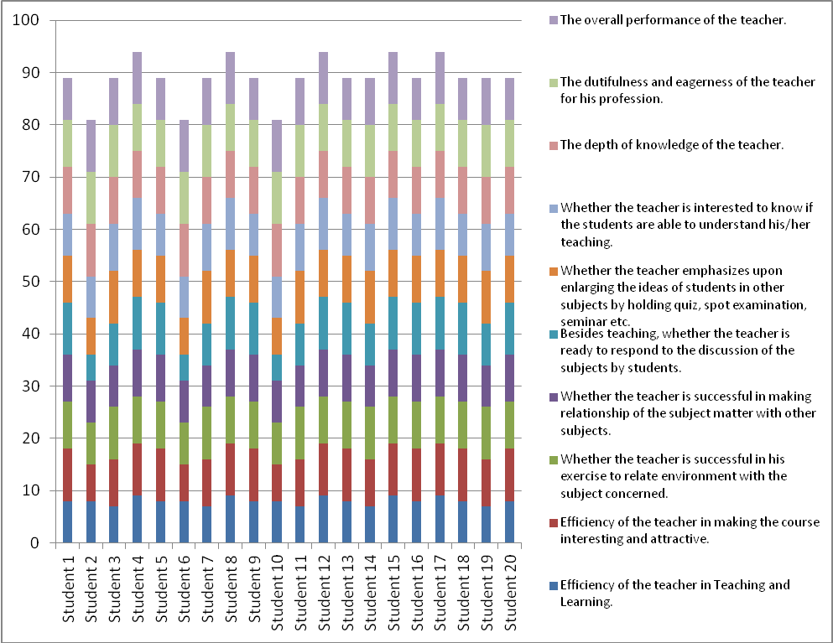

Note: Action taken on Analysis Report

- The evaluation is made by means of a questionnaire of 10 questions and the results are analyzed by IQAC.
- IQAC prepared analysis report (graphical) of each teacher separately and submitted the same to the Principal.
- The Principal of the college discussed the results of the student evaluation of each teacher and discussing his/her weaknesses and strengths confidentially.
- The Principal and other authorities advised the teacher to improve performance. The teacher also became aware of his/her weaknesses and strengths. The results of the evaluation were not used to victimize the teacher.

